Manjaro Linux
Enjoy the simplicity
News Wiki Forum Download Mirrors Mailing-Lists Team About Archive

Manjaro Update 2015-09-20 (stable)
I’m happy to announce another review cycle for Manjaro 15.09.
It is time for our third release candidate of Manjaro 15.09. Only small adjustments were made. Most of our kernels got updated: 3.10.88, 3.12.48, 3.14.52, 4.1.7. We also added kernel 4.3-rc1 for early testing. However not all extramodules built for that kernel series yet. Octopi 0.7.2 got some needed fixes...
Written on September 20, 2015
READ MORE

Manjaro Update 2015-09-14 (stable)
I’m happy to announce another review cycle for Manjaro 15.09.
It is time for our second release candidate of Manjaro 15.09. Only small adjustments were made. We fixed for example our 4.1 kernel series by backporting overlayfs from 4.2 and Plasma got updated to 5.4.1. Linux316 got updated to 3.16.7.17 such as mesato 10.6.7 and spl/zfs to 0.6.5. Small...
Written on September 14, 2015
READ MORE

Manjaro-Mate 15.09 released
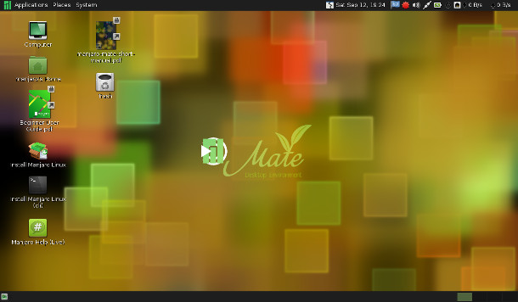
The Manjaro Community is proud to present our new Mate Edition. Manjaro-Mate aims to be light, fast and resource friendly, yet at the same time complete and ready to use for all typical everyday office- and multimedia-needs. The applications are easily accessible from the traditional Gnome 2 menu. This edition features the current Mate 1.10 as well...
Written on September 12, 2015
READ MORE

Manjaro Update 2015-09-07 (stable)
I’m happy to announce the first release candidate for Manjaro 15.09.
It is time to release another stable release. Therefor we started to work on Manjaro 15.09. We will use kernel 4.1 LTS for this release and ship Calamares as an alternative graphical installer.
With this update we pushed out a new Mate 1.10.2, Linux 3.13.11.26, 3.18.21, 3.19.8.6,4.1.6-3,...
Written on September 7, 2015
READ MORE
« Prev 1 2 3 4 5 6 7 8 9 10 11 12 13 14 15 16 17 18 Next »
All trademarks and registered trademarks are the property of their respective owners.

